Problem Solving and Flowcharts

A person needs to setup an appointment for the dentist. The person has a date calendar that tracks their activities. The person needs to get a suggested date for an appointment, check their calendar to see if the suggested date conflicts with an already scheduled activity. If so, then get another suggestion. Continue this until an appointment can be made.
Understand the problem
- Goal is to obtain a dental appointment
- Check my personal calendar
- Don’t leave without an appointment

Define Inputs, Outputs and Constraints
Inputs | Outputs | Constraints
- Date and time  - Calendar of scheduled activities | - Recorded appointment date/time | - No overlapping activity

Decompose the Problem into major processing steps
- Get suggested appointment date/time
- Check calendar
  - Yes, take appointment date/time
  - Repeat with a new suggestion
- Register appointment in calendar

Flowchart
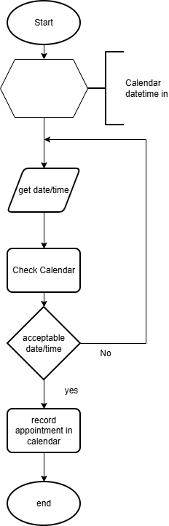
Test
- Check logic (walk-thru)
- Check symbols
- Refine if possible
What if we were given a “language” based flow of control for a solution.

Input date-time for appointment
If date-time is free in calendar, accept
If date-time is not free in calendar, repeat above with new date-time
If accepted, record in personal calendar

Interpret what is happening.
The process is obtaining a appointment for an activity. The process starts with obtaining a suggested appointment date and time; check against a personal calendar. If the appointment fits the calendar, accept and record the appointment else repeat with a new date/time.

Could one refine the statements above:

Repeat until acceptable date/time
Input date-time for appointment
If date-time is free in calendar, accept
Record appointment date/time in personal calendar

